Order processing And stock recording system
  - User Guide
July 2019



Preface
Thank you for purchasing Order and Processing System (Hereafter referred to as the “OPSR”).
Before using the OPSR, be sure to read this guide thoroughly to familiarize yourself with the OPSR’s operation procedures and functions.

Note
- It is forbidden to copy the contents of this manual in whole, or in part, without the permission of the Smart & Luxury Motor Company (SLMC).
- The information in this manual is subject to change without notice.
- This manual was written with care; however, if you should find any error or omissions, please contact us and inform them of your findings.
- Regardless of the above clause, Smart & Luxury Motor Company (SLMC) shall not be held responsible for any damages or third-party claims for damages or losses resulting from the use of this product.

Table of Contects

User Login
A user may login by entering their username, password.
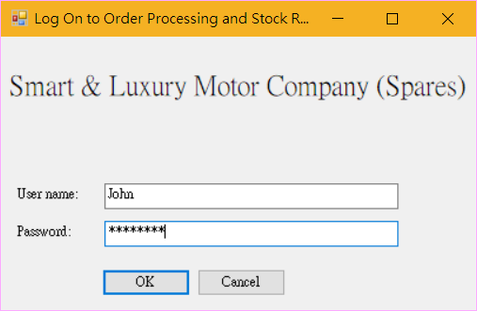

Troubleshooting
The user name or password is incorrect! Try again.
The user name or password is incorrect
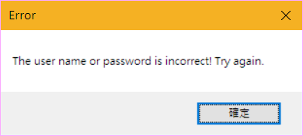

No server connected! Try again later.
The server connection may be lost contact the system Administrator
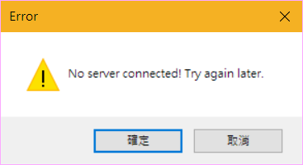

Menu
The Menu is a graphical user interface. It provides a central launching point for all functions and performing other tasks.
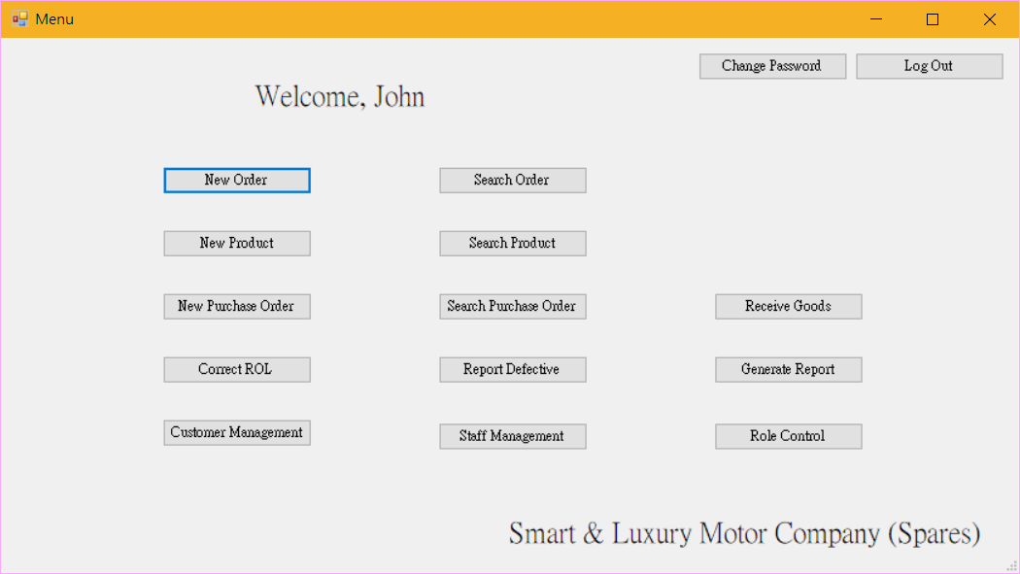

Troubleshooting
The buttons are disabled.
It is because the user does not have the correct permission to launch the function.
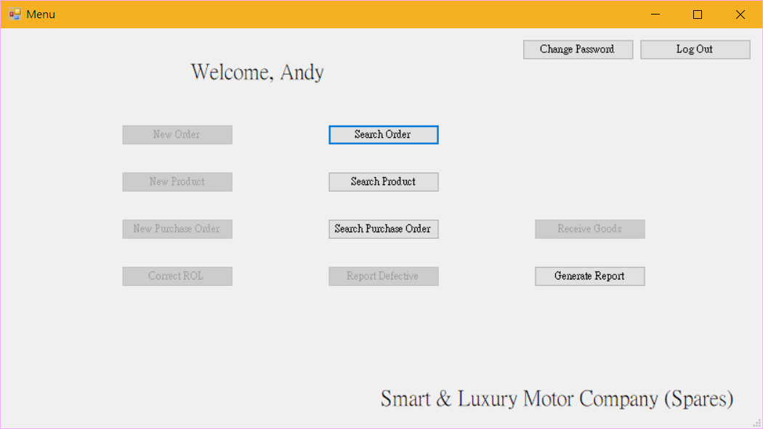

Place new order
For placing a new order, the required position are Salesmen and Sales Office Manager.
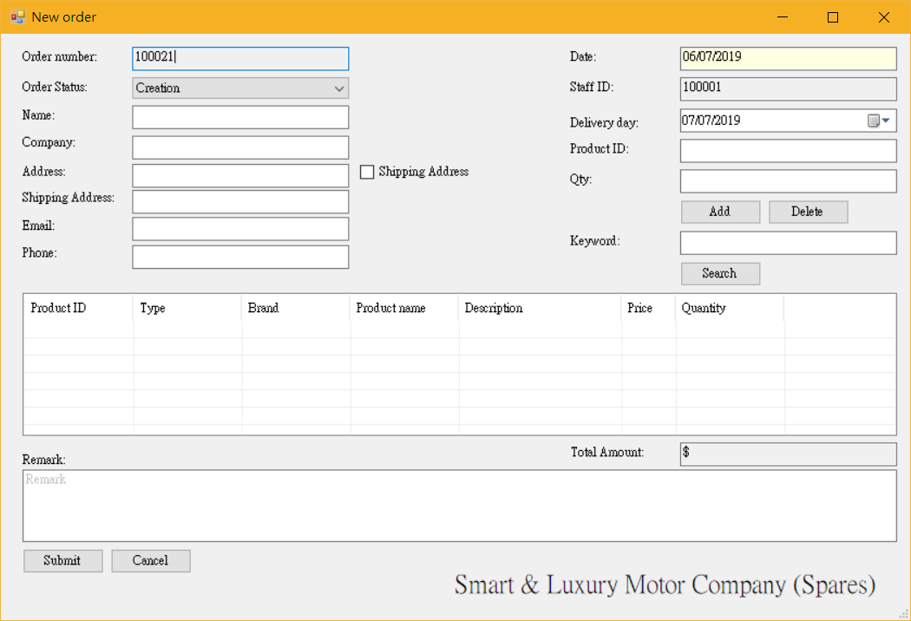
Note: All fields must be filled. If it were otherwise, OPSR would be interrupted with an error message.
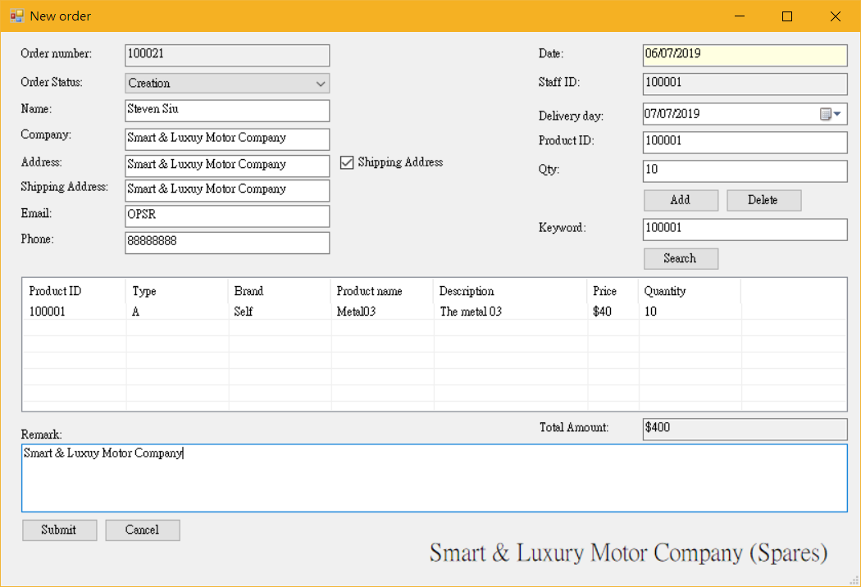

Placing Order with Searching Product
For the product that the order required, the search function is unnecessary.
Procedure:
- On the OPSR, select the [Search] from the [New order] function.
- The following window will appear. Type in the keyword of the product.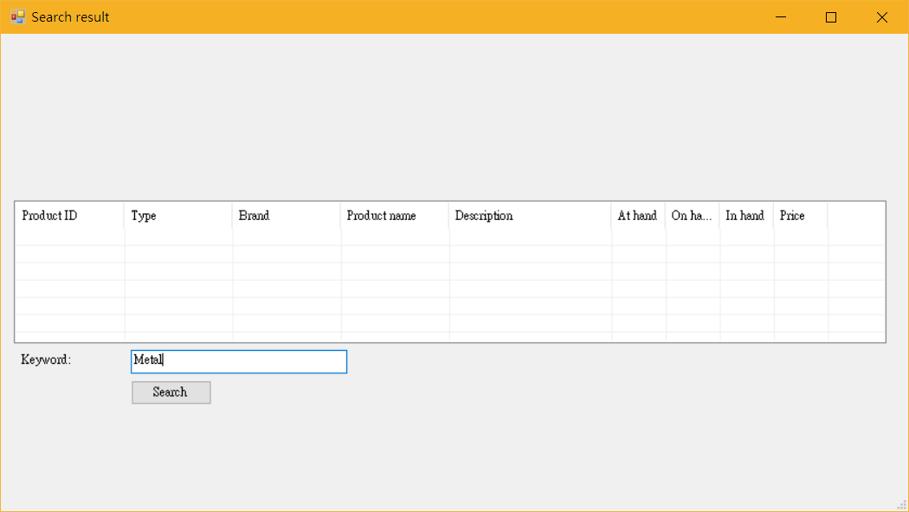
Note: You can Type in the Keyword field from New order window to search directly.
- Select [Search]. The product that match the keyword will appear.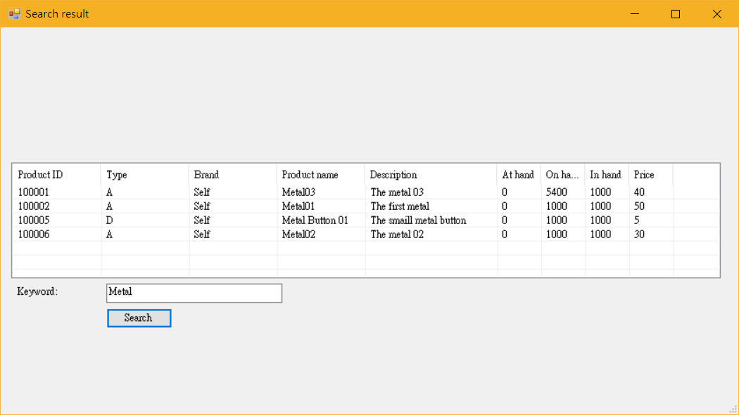
- Double click the product that match the order. The Product ID of the product will send back to New order window.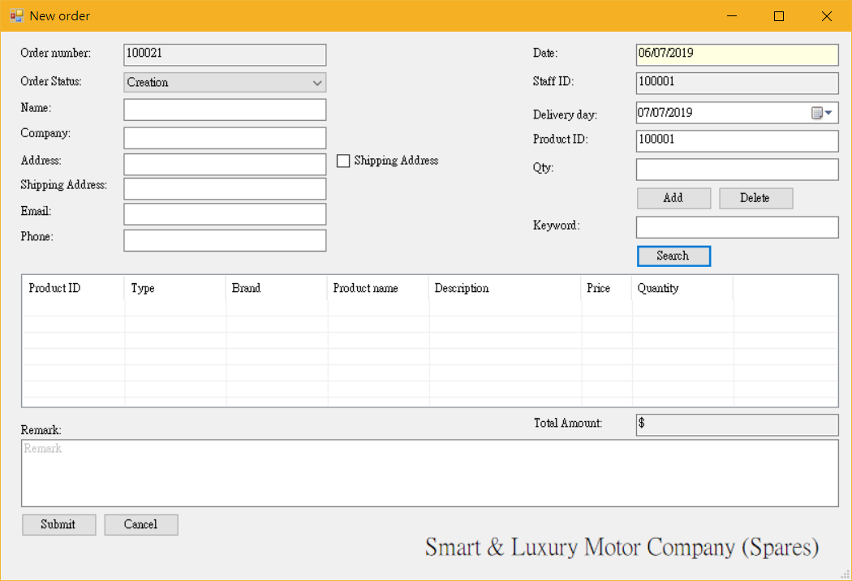
- Type the quantity of the product in [Qty] field and select [Add].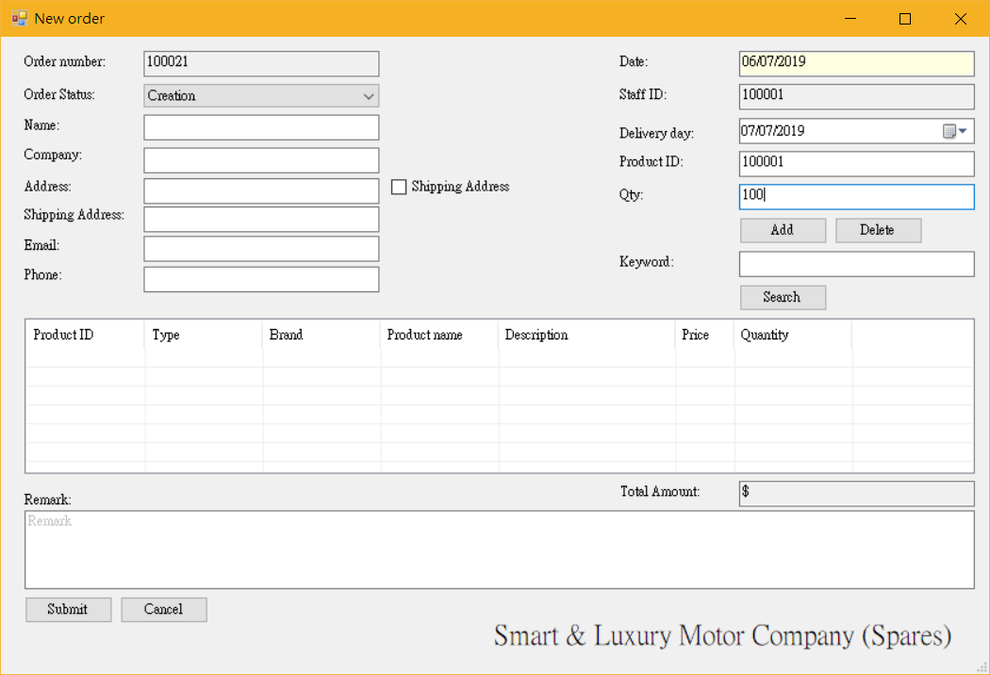
Note: Select [Delete] to delete the product from the order.
- The product will appear in the order.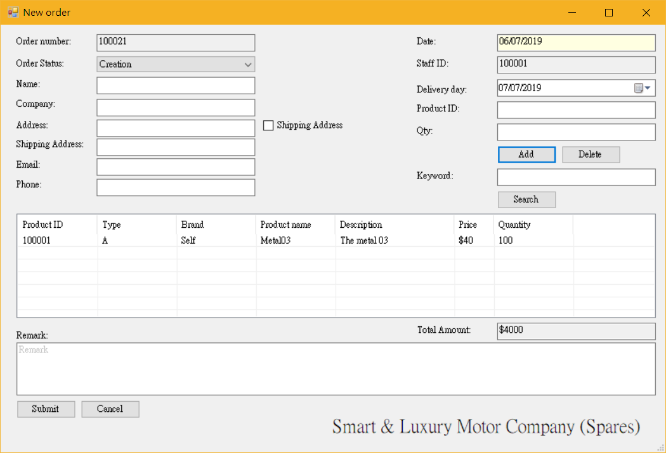
- Repeat those procedure until meet the order requirement.
- Select [Submit]. The order will submit.
- Or select [Cancel] to cancel the order.

Search Order
There is the function for search of order.
The Searching Order function is location in the Menu.
Search order procedure is as follows.
- Select [Search Order] from the Menu. The following window will appear.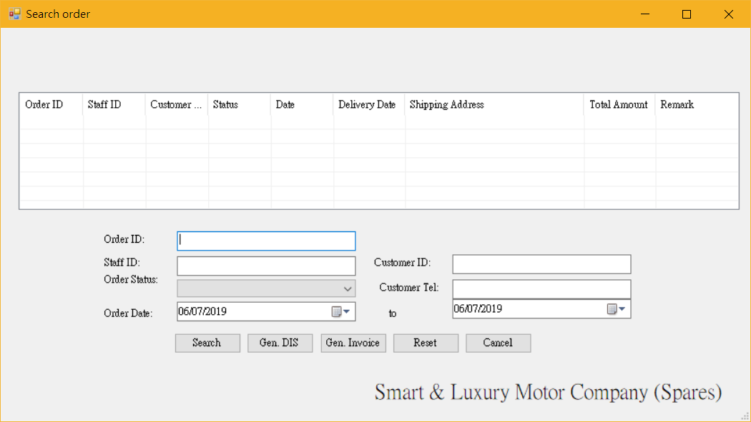
- Enter the information of the order and select [Search]. The order that match the requirement will appear.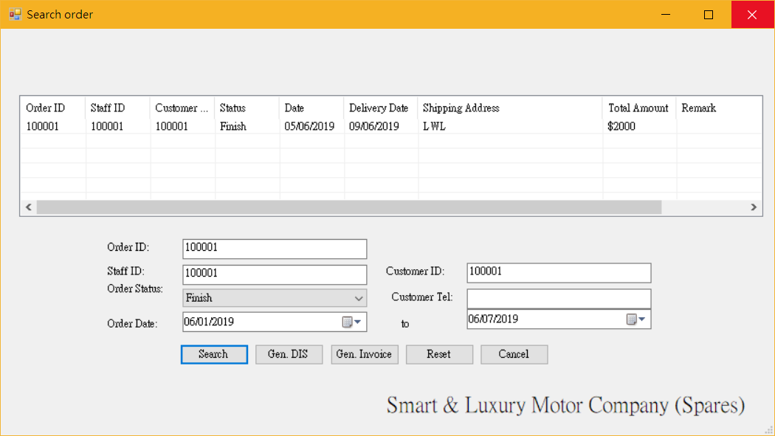
- Select [Reset]. All condition will reset.

Edit Order
When the order gets wrong, the edit order feature has following function.
- Change of order status.
- Change of customer information.
- Change of delivery date.
- The despatched number of products.
- Select [Search Order] from the Menu and search the order that you want to edit.
- Double click the order from the list. The Edit order window will appear.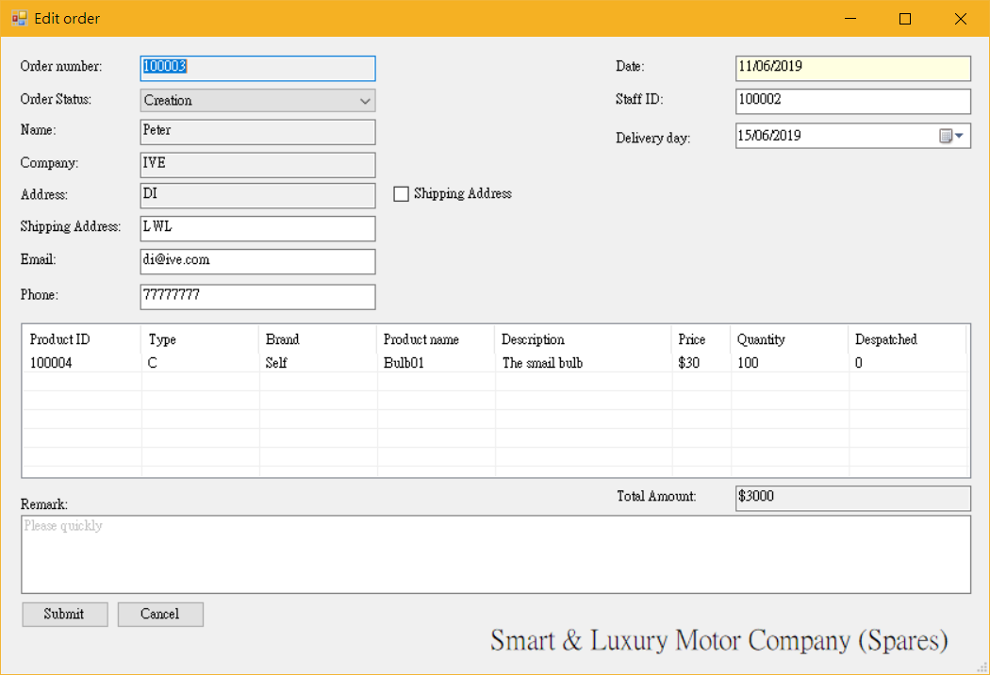
- Choose the field to edit.
- After edit, select [Submit] and end.
Mote: Or select [Cancel] to cancel the change.

Generate Despatch Instruction Set
- Select [Search Order] from the Menu and search the order that you want to generate the Despatch Instruction Set.
- Select [Gen. DIS]. The Despatch Instruction Set will generate at the OPSR root folder.
- The sample of Despatch Instruction Set.

  - Generate Invoice
- Select [Search Order] from the Menu and search the order that you want to generate the Despatch Instruction Set.
- Select [Gen. DIS]. The Despatch Instruction Set will generate at the OPSR root folder.
- The sample of Invoice.

Add New Product

